RPC_coolingPipe_Test10_Ar_2011-10-27_3h52m15.txt
Object: RPC copper pipe of 3m with to sagana fitting, cap on one end
Place: 158
Gas: Argon
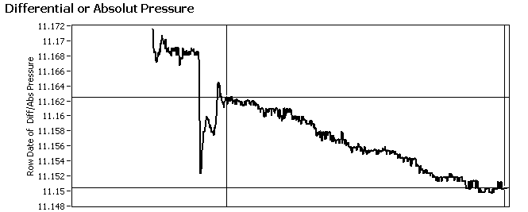
Cursor Start: 213 – Data Length: 590 points (60s/point)
Start Pressure: 11162 mbar - End Pressure: 11150 mbar
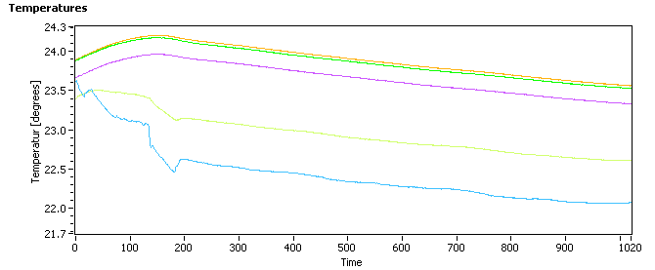
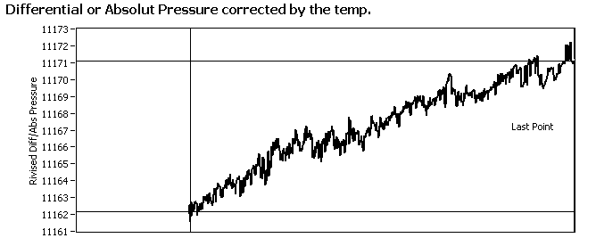
Cursor Start: 0 – Data Length: 803 points (60s/point), corrected by All Temp Sensors
Start Pressure: 11162mbar - End Pressure: 11171 mbar

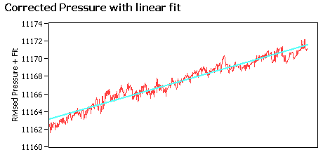
Leak rate: xxxx mbar*l/s (positive slope)
V: 0.1 liter (v)
Time: 48180 s (t)

